**Healthier CACFP Award**

**Application**

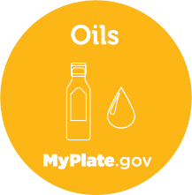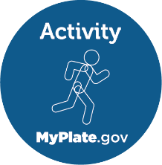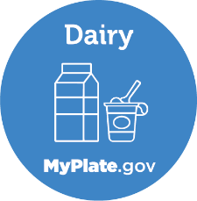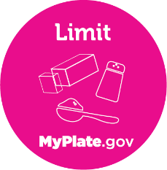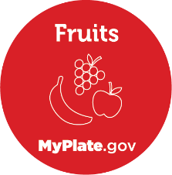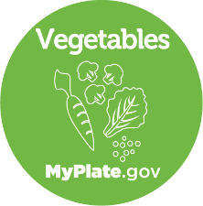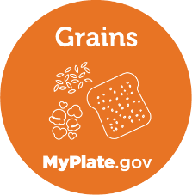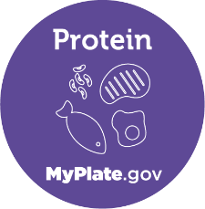

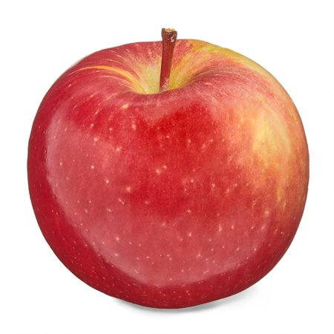

Recognizing Excellence in

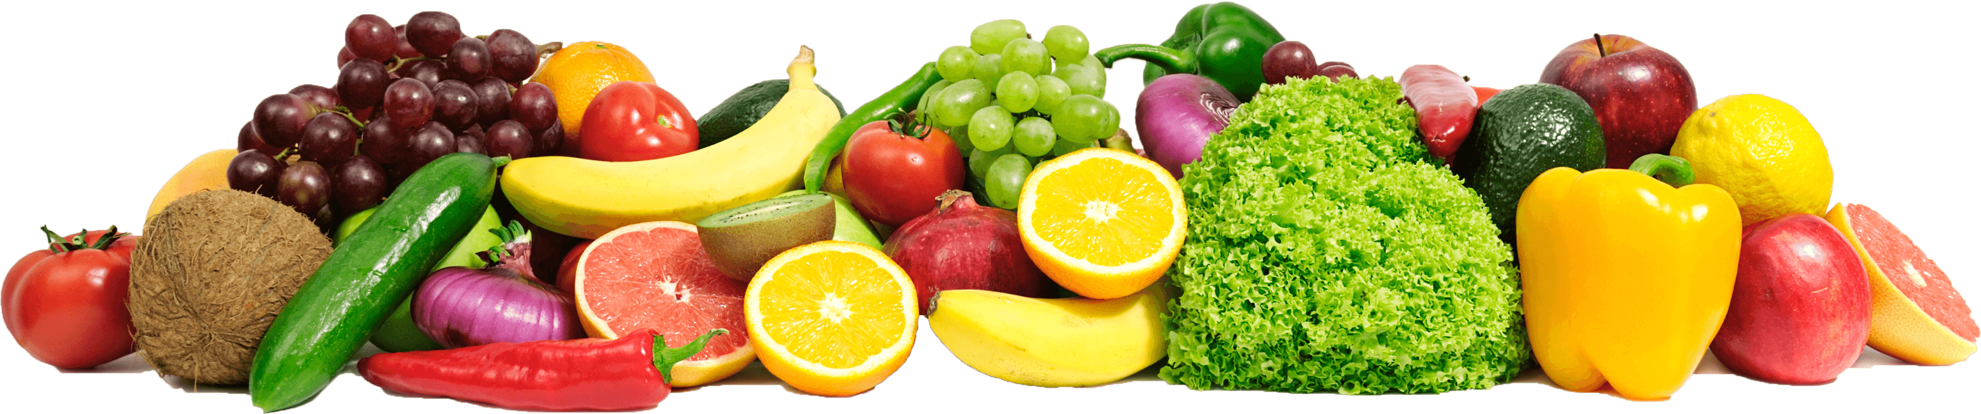Nutrition and Physical Activity in Child



**CACFP**

**Child & Adult Care**

**Food Program**

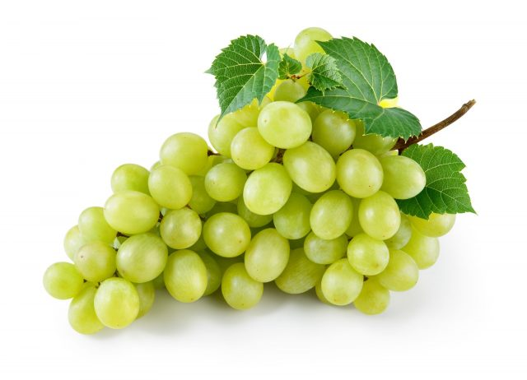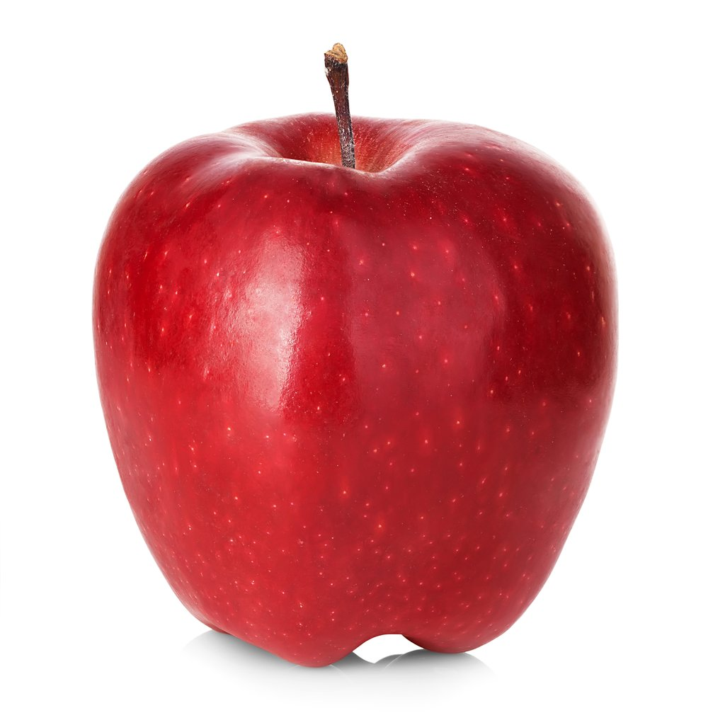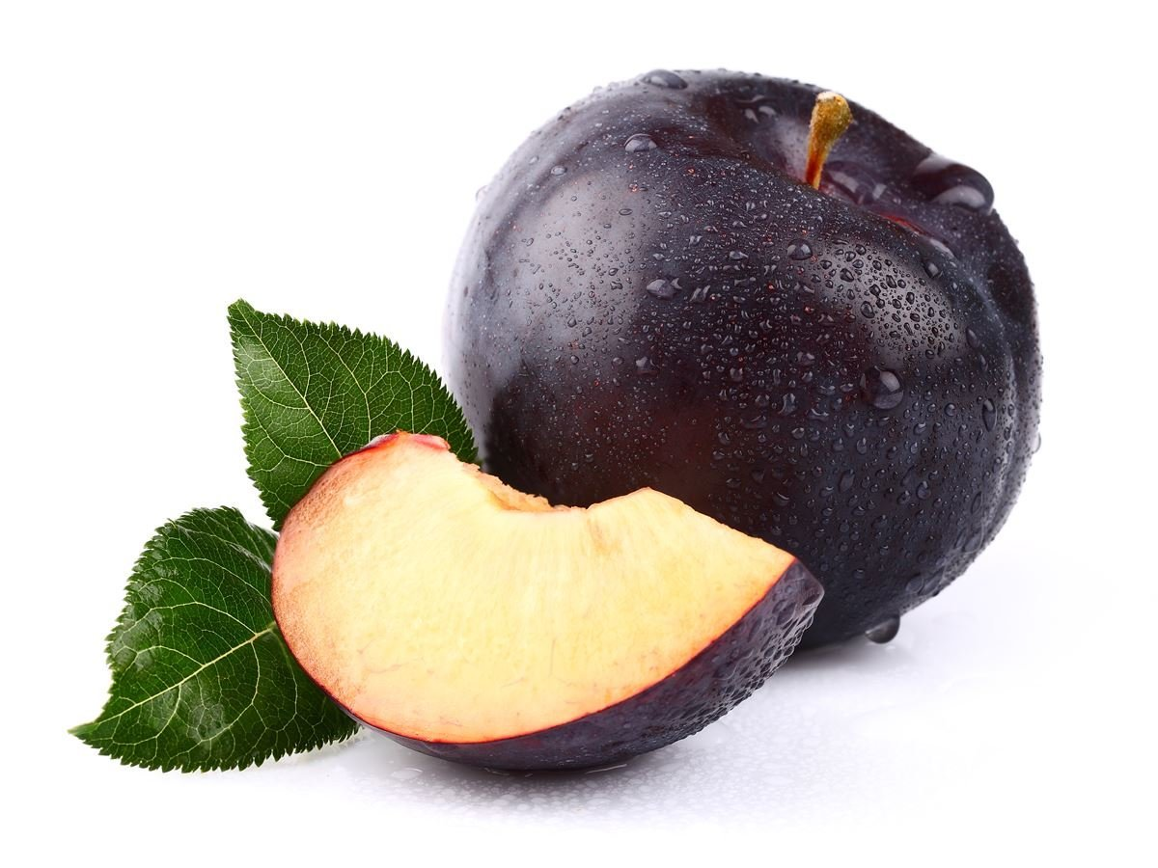

Revision 2024 Care

**Table of Contents**

General Information ………………………………………………………………………………………………………………… pg. 3

Application Cover Sheet ……………………………………………………………………………………………………………pg. 4

Category 1: Menus Criteria ……………………………………………………………………………………………………… pg. 5‐7

Category 2: Physical Activity Criteria ………………………………………………………………………………………. pg. 8-9

Category 3: Professional Development Criteria ………………………………………………………………………. pg. 10‐11

Category 4: Nutrition and Wellness Environment Criteria ………………………………………………………. pg. 12‐14

Category 5: Infant Care Criteria ……………………………………………………………………………………………… pg. 15

Application Verification Form …………………………………………………………………………………………………. pg. 16

Home Sponsoring Organization Verification Form…………….…………………………………………………... pg. 17

USDA Nondiscrimination Statement………………………………………………………………………………………. pg. 18

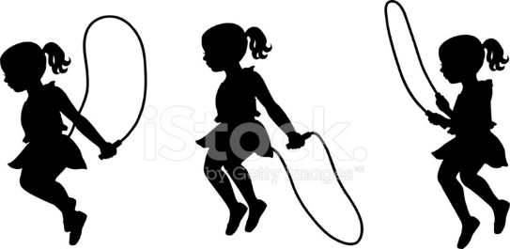

Page2

**General Information**

**What is it and why is it important?**

The Healthier Child and Adult Care Food Program (CACFP) Award is a recognition system that supports the wellness efforts of child care providers, day care center staff, and home providers (referred to as “caregiver” going forward) participating in CACFP. Caregivers going above and beyond the Program requirements by taking steps to improve the menus, physical activity, professional development, nutrition, and wellness environment and/or infant care can apply for an award in one or more of these categories. Three award levels are offered: Honors, High Honors and Highest Honors. Child caregivers have an opportunity to positively impact children’s healthy development by encouraging children to develop healthy habits at a young age.

**Am I eligible to apply?**

Participation in the CACFP and compliance with CACFP regulations is required to be eligible for the award. Meeting the award criteria and receiving an award does not replace CACFP requirements. Applicants are required to be in good standing with the CACFP, defined as having completed and implemented all corrective actions from the most recent compliance review with no serious deficiencies in the past two program years, at the time of application. CACFP daycare centers, family daycare homes and At-Risk Afterschool Care programs are all welcome to apply. Adult day care centers can apply for the menus, physical activity, professional development and nutrition and wellness environment, infant care is not applicable for these centers. This is not an award for Emergency Shelters. The award recognizes caregivers that go above and beyond Federal requirements (7 CFR PART 226).

**How do I apply?**

The Healthier CACFP Award application includes criteria in five categories: Menus, Physical Activity, Professional Development, Nutrition and Wellness Environment and Infant Care. Applicants can choose which category(ies) they would like to apply for and at which level. Home caregivers should submit applications to the Home Sponsor for compliance verification (Home Sponsor signs the Home Sponsoring Organization Verification Form then sends the completed application to the State agency). Centers should submit applications directly to the agency or organization with which they hold a Program agreement (either the State agency or a sponsor of centers). Applications must include submission of the requested support documentation as listed in the “Evaluation” columns in the application. Instructions should be read carefully in each category to determine which criteria need to be met to achieve the different award levels. It is recommended that applicants utilize the *Healthier CACFP Award Resource Book*, which explains the “why” for each criterion and provides guidance and tools to assist with implementing the criteria.

**How am I recognized?**

Winners are recognized with awards issued jointly by the USDA, Food and Nutrition Service, and State agencies that showcase the caregiver’s achievement. Award recognition includes an award certificate (one for each award category achieved) and a congratulatory letter to your organization. Winners will be recognized in March during National CACFP Week.

**What is the award time period?**

Applications can be completed anytime throughout the year, up until September 30th which is the end of the fiscal year. State agencies must submit applications to the Regional Office by November 15th. The Regional Office will review and determine awards by January/February. Awardees will be announced in March during National CACFP Week. The award certificate will be labeled for the year given with no expiration date.

Page3

**Application Cover Sheet**

Award level applying for: (awards are explained by category/level in the Healthier CACFP Award Resource Book)

Honors  High Honors  Highest Honors

Application for (check all categories applying for):

Menus  Physical Activity  Professional Development

Nutrition and Wellness Environment Infant Care

Type of CACFP Provider:

Daycare Center  Daycare Home  Adult Day Care Center

At-Risk Afterschool Care Program

Home Provider/Center Name:

Home Provider/Center Address:

Age Range of Children in Care:

Contact Person’s Name & Title:

Contact Person’s Phone Number & Email:

Date Submitted to State Agency:

**State Agency**

Approved by State Director:

Signature Date

**Regional Office**

Award Issue Date:

Approved by RO Nutritionist:

Signature Date

Page4

|  |  |  |  |  |
| --- | --- | --- | --- | --- |
| *General Criteria* | Award Level General Requirements | | | Evaluation |
| Honors High Honors Highest Honors | | |
| All corrective actions from the most recent compliance review have been completed and implemented. Program has not been seriously deficient in the past two program years. | **√** | **√** | **√** | State Agency to verify prior to submitting application to Regional Office |
| *Category 1: Menus* | Award Level General Requirements | | | Evaluation |
| Honors High Honors Highest Honors | | |
| **MENUS for children over the age of one year** | | | | |
| Reimbursable meals meet the USDA requirements. All meals meet the CACFP meal patterns. | **√** | **√** | **√** | Submit four consecutive weeks of menus |
| **Reviewed menus meet the criteria below:** |  | | | |
| Variety of Fruits and Vegetables Served1  Fresh Fruits and Vegetables:   * Fresh vegetables must be served each week at least: * Fresh fruit must be served each week at least:   A different fruit/vegetable1 is served at each meal/snack over the course of a day.  Vegetable Subgroups3:   * Dark green vegetables served once per week. * Red and/or orange vegetables served once per week. * Beans and peas (legumes) served once per week.   Pre-fried4, breaded vegetables (i.e., tater tots, French fries, onion rings) are limited to:  If snack is served, at least 1 of the 2 required components is a vegetable or a fruit. | 2x/week  2x/week  √  √  √  √  < 2x/month  3x/week | 3x/week  3x/week  √  √  √  √  < 1x/month  4x/week | 4x/week  4x/week  √  √  √  √  Never Served  5x/week | Describe fruit and vegetables on menu as canned, fresh, or frozen. (i.e., may manually write “canned”, “fresh” or “frozen” on menu)  Identify vegetable subgroups on menu (i.e., may manually write the subgroup on menu) |

1 Fruits and vegetables must be of appropriate texture based on the child’s development to prevent choking.

2 Fruit may be fresh, frozen, canned, or dried. Dried fruit must have no added sweetener; canned fruit must be packed in juice or light syrup.

3 Includes but not limited to - Dark Green: broccoli, spinach, raw leafy greens. Red/Orange: carrots, red peppers, sweet potatoes, tomatoes. Beans and Peas: black beans, kidney beans, lentils, refried beans, pinto beans, navy beans, great northern beans (does not include green beans and green peas).

4 Includes foods that are pre-fried, flash-fried, or par-fried by the manufacturer, such as tater tots, French fries, or onion rings. Deep fat-fried foods (cooked by submerging in hot oil or other fat) that are prepared on-site are prohibited. Cooking methods such as sautéing, or pan-frying is acceptable.

Page5

|  |  |  |  |  |  |
| --- | --- | --- | --- | --- | --- |
| *Category 1: Menus* | | Award Level General Requirements | | | Evaluation |
| Honors High Honors Highest Honors | | |
| **MENUS for children over the age of one year** | | | | | |
| 100% Juice is limited to: | < 2x/week | | < 1x/week | Never Served | Identify when served on menu |
| Milk  Serve only unflavored milk to ALL participants. Low-fat (1% or less) and/or fat free (skim) are served to participants over 2. Only whole milk is served to participants between the ages 1-2. | **√** | | **√** | **√** | Identify type of milk and  age groups served on menu. |
| Grains  Whole grain-rich foods5 are served.  Sweet crackers (including graham crackers and animal crackers) are limited to:  Grain-based desserts6 are never served as an additional food item that is not contributing to the reimbursable meal. (holidays and birthdays are exempt) | 2x/day  < 1x/week  **√** | | 2x/day  (minimum of two different types of whole grain-rich foods must be offered each week)  < 2x/month  **√** | All grains served must be whole grain-rich  (minimum of three different types of whole grain-rich foods must be offered each week)  Never Served  **√** | Identify whole grain-rich items on menus.  Submit ingredient  list for whole grain-rich items.  Submit ingredient list and/or recipe for homemade items. |

5 Whole grain-rich foods are foods that contain 100 percent whole grains, or that contain at least 50 percent whole grains and the remaining grains in the food are enriched.

6 Grain-based desserts are those items that are denoted with a superscript 3 or 4 in the Food Buying Guide for Child Nutrition Programs Exhibit A. The following foods are considered grain-based desserts: cookies, sweet pie crusts, doughnuts, cereal bars, breakfast bars, granola bars, sweet rolls, toaster pastries, cake, and brownies.

Page6

|  |  |  |  |  |  |
| --- | --- | --- | --- | --- | --- |
| *Category 1: Menus* | Award Level General Requirements | | | | Evaluation |
| Honors High Honors Highest Honors | | | |
| **MENUS for children over the age of one year** | | | | | |
| Meat/Meat Alternates  Higher fat meats and entrees that are processed and preserved7 are limited to:  Incorporate lean meats8, nuts/seeds, and/or tofu into menu (to contribute to the meat/meat alternate component vs. as an extra).  Serve only natural cheese and choose low-fat or reduced-fat cheeses. | | < 1x/week  **√**  **√** | < 2x/month  **√**  **√** | Never Served  **√**  **√** | Identify on menu if the items are homemade (i.e., may manually write “homemade” on menu).  Identify cheese types on menu (i.e., may manually write “low fat”, “natural” or “reduced” on menu). |
| Incorporate locally produced food into meals. | | 2x/month | 3x/month | 4x/month | Identify locally produced items on menus |
| Non-creditable sweetened foods are limited9. | | < 2x/week | < 1x/week | Never Served | Identify when served on menu |
| Incorporating foods from different cultures | | 2x/month | 3x/month | 4x/month | Identify cultural foods on menus |

7All meat or poultry products preserved by smoking, curing, salting and/or the addition of chemical preservatives. Processed meats and poultry include all types of meat and poultry sausages (bologna, frankfurters, luncheon meats and loaves, sandwich spreads, Vienna, chorizo, kielbasa, pepperoni, salami, and summer sausages), bacon, smoked or cured ham or pork shoulder, corned beef, pastrami, pig’s feet, beef jerky, and smoked turkey/chicken products.

8 Examples include 95% lean cooked ground beef, beef top round steak or roast, beef tenderloin, pork top loin chop or roast, pork tenderloin, ham or turkey deli slices, skinless chicken breast, and skinless turkey breast.

9 Non-creditable sweetened foods are sources of added sugars, such as sweet toppings (e.g., honey, jam, syrup), mix in ingredients sold with yogurt (e.g., honey, candy, or cookie pieces).

Page7

Page7

Page8

|  |  |  |  |  |  |  |  |  |
| --- | --- | --- | --- | --- | --- | --- | --- | --- |
| *General Criteria* | | Award Level General Requirements | | | | | Evaluation | |
| Honors High Honors Highest Honors | | | | |
| All corrective actions from the most recent compliance review have been completed and implemented. Program has not been seriously deficient in the past two program years. | | **√** | | **√** | | **√** | State Agency to verify prior to submitting application to Regional Office. | |
| *Category 2: Physical Activity*  Page7 | Award Level General Requirements | | | | | | | Evaluation |
| Honors High Honors Highest Honors | | | | | | |
| Television, DVD, and video watching, and computer use is limited or not available for children under the age of two. | **√** | | **√** | | **√** | | | Submit written policy. |
| For children over two, screen time1 (educational/movement  Material) is limited to: | No more than 30  minutes/day | | No more than  15 minutes/day | | No more than 30 minutes/week | | | Submit written policy and submit copies of daily schedules highlighting screen time. |
| Moderate to vigorous physical activity2 is provided during each full day of care (8 to 9-hour day) for at least: | 45-60 minutes | | 60-90 minutes | | 90-120 minutes | | | Submit written policy and submit copies of daily schedules highlighting moderate and vigorous activity. |
| Periods of inactivity (at one time), excluding nap time and mealtimes, are limited to: | < 30 minutes on  2 occasions/day  **or**  < 60 minutes on  1 occasion/day | | < 30 minutes on  1 occasion/day | | < 15 minutes at a time | | | Submit written policy and submit copies of daily schedules highlighting the periods of inactivity. |
| The physical activity provided during each full day of care (8+ hour day) includes:  o Both indoor and outdoor activities,  o Incorporate movement in a fun way; (unstructured), and  o Structured physical activity (age-appropriate activities guided by the caregiver) | **√**  At least 30 minutes  At least 30 minutes | | **√**  At least 45 minutes  At least 45 minutes | | **√**  At least 60 minutes  At least 60 minutes | | | Submit written policy and submit copies of daily schedules highlighting the periods of inactivity. |
| Active play time is not restricted as punishment. | **√** | | **√** | | **√** | | | Submit written policy. |
| 1Television, DVD, video watching, cell phone use (playing games) and computer use.  2Examples include walking, biking, swimming, gymnastics, etc. | | | | | | | | |
| |  |  |  | | --- | --- | --- | | *Category 2: Physical Activity*  Page7 | Award Level General Requirements | Evaluation |   Award Level General Requirements  Evaluation | | | | | | | | |
| Make drinking water freely available, both indoors and outdoors, throughout the day. | **√** | | **√** | | **√** | | | Submit written policy. |
| During outdoor physical activity, adults and children have access to sunscreen of SPF 15 or higher. Follow State Health Department guidelines on sunscreen application. | **√** | | **√** | | **√** | | | Submit written policy. |
| Physical activity curriculums, which encourage a variety of basic movement and manipulative skills, are utilized at least weekly. |  | | **√** | | **√** | | | Submit written policy and copies of physical activity curriculums utilized. |
| Physical activity ideas and resources are sent home with parents at least monthly. |  | |  | | **√** | | | Submit a sampling of the parent correspondence (e.g., newsletter, email, social media, etc.) which contain this information. |

Page9

|  |  |  |  |  |  |
| --- | --- | --- | --- | --- | --- |
| *General Criteria*  Page10 | Award Level General Requirements | | | | Evaluation |
| Honors High Honors Highest Honors | | | |
| All corrective actions from the most recent compliance review have been completed and implemented. Program has not been seriously deficient in the past two years. | **√** | **√** | | **√** | State Agency to verify prior to submitting application to Regional Office. |
| *Category 3:*  *Professional Development* | Award Level General Requirements  Honors High Honors Highest Honors | | | | Evaluation |
| 1. Director or Authorized Representative1 attended an online or in-person CACFP Meal Pattern training **in the past year** provided by a State Agency, Sponsoring Organization, or Institute of Child Nutrition (ICN)   AND   1. Director or Authorized Representative1   AND  Designated Staff2 - tailor personal development in the area of wellness knowledge to individual staff needs and maintain a tracking log. *  To receive an award both the director/authorized representative must have completed **both** items  listed above and the designated staff | **√**  8 hours/year  4 hours/year | | **√**  10 hours/year  6 hours/year | **√**  12 hours/year  8 hours/year | Submit copies of training attendance records or training certificates.  Submit personal development training tracker tool for the director and designated staff.  At least 1 staff person other than the director must be included (unless there is only one person such as in a home). |
| 1 Director or Authorized Representative is defined as the person who is the authorized to receive reimbursement for the CACFP. This includes a Daycare Home Provider.  2 Designated Staff are defined as staff specifically involved in child wellness, including planning, preparing, and serving the CACFP meals.  * Online or in-person trainings provided by USDA FNS, USDA SNAP-Ed, State Agency, Sponsoring Organization, State Extension programs, ICN and/or Professional Organizations. Training topics may include breastfeeding promotion, child wellness, developmental feeding practices, CACFP meal patterns, food safety and/or food allergies. Examples of acceptable online professional development trainings are listed on the following page.  Page 10 | | | | | |
| Examples of online wellness training opportunities that may be used to meet personal development training criteria (this is not an all-inclusive list):   * CACFP Halftime: Thirty on Thursdays Training Webinar Series: <https://www.fns.usda.gov/tn/halftime-cacfp-thirty-thursdays-training-webinar-series> (30 minutes each) * ICN Online Trainings: <https://theicn.docebosaas.com/learn/course> * Food Safety in Child Care: (4 hours) * Care Connection - Planning Cycle Menus in Child Care: (2 hours) * CARE Connection ‐ Planning Snacks as an Education Activity: (1 hour) * CARE Connection ‐ Serving Nutritious Foods in Child Care: (2 hours) * CARE Connection ‐ Step‐by‐step Menu Planning in Child Care: (4 hours) * Family Child Care FUNdamentals: (7 hours) * Food Allergies in SNPs: (1hour) * Colorado Department of Public Health and Environment – Calendar with training information, online resources, and training materials.   [CACFP Training/Online Resources | Department of Public Health & Environment (colorado.gov)](https://cdphe.colorado.gov/child-and-adult-care-food-program-cacfp/cacfp-training/online-resources)   * Kansas Department of Education - Online Classes   A current list of online training classes is posted at [www.kn-eat.org](http://www.kn-eat.org), Access to the KSDE Training Portal - <https://learning.ksde.org/> for online trainings.   * Iowa Department of Education – CACFP Wellness Courses: [CACFP Online Trainings | Iowa Department of Education (educateiowa.gov)](https://educateiowa.gov/pk-12/nutrition-programs/education-events-cacfp/cacfp-online-trainings) * Smarter Mealtimes: [Smarter Mealtimes at TCCI - Resources and Info — TCCI Wellness](https://tcciwellness.com/smarter-mealtimes/) * National Smarter Mealtimes for Child Care Settings Scorecard - [SMM-Scorecard-v4 (cacfp.org)](https://www.cacfp.org/assets/pdf/Smarter+Mealtime+Scorecard+cacfp.org/) | | | | | |

Page11

Page12

|  |  |  |  |  |  |  |  |  |
| --- | --- | --- | --- | --- | --- | --- | --- | --- |
| *General Criteria* | Award Level General Requirements | | | | | | Evaluation | |
| Honors High Honors Highest Honors | | | | | |
| All corrective actions from the most recent compliance review have been completed and implemented. Program has not been seriously deficient in the past two program years. | **√** | | **√** | | **√** | | State Agency to verify prior to submitting application to Regional Office. | |
| *Category 4: Nutrition and Wellness Environment*  Page9 | | Award Level General Requirements | | | | | | Evaluation |
| Honors High Honors Highest Honors | | | | | |
| **Directions specific to this section:**  **Create a written policy outlining your commitment to creating a healthy nutrition and wellness environment for all children.** | | **All checked All checked All checked plus 6 plus 10 plus 15 additional additional additional** | | | | | | |
| Complete the National Smarter Mealtimes for Child Care Settings Scorecard at least once per year.  <https://www.cacfp.org/assets/pdf/Smarter+Mealtime+Scorecard+cacfp.org/> | | **√** | | **√** | | **√** | | Submit completed scorecard(s). |
| Written policy is shared with parents and reviewed on an annual basis (or more often as needed). | | **√** | | **√** | | **√** | | Submit written nutrition and wellness environment policy containing all of the required elements to meet the specific award level.  Page13 |
| Implements age appropriate CACFP family style meal service including using child size serving utensils and the caregiver seated at the table with and eating the same food as the children. | |  | |  | |  | |
| The daily schedule promotes a relaxed and adequate period for meals and snacks. Children have ample time to eat and practice social interaction skills such as having a conversation. | |  | |  | |  | |
| Food is not used as incentive or punishment and children are not punished or rewarded for what they choose to eat. Food is not withheld as punishment and children are not forced to eat foods as a prerequisite to receiving an item or completing an activity. | |  | |  | |  | |
| Children are instructed in hand washing techniques and both children and staff wash their hands before and after meals and snack. | |  | |  | |  | |
| Menus are available and shared for staff and parents. Children and parents have opportunities to provide input on the food and menus. | |  | |  | |  | |
| Children are taught developmentally appropriate table manners; staff are trained and model the manners. | |  | |  | |  | |
| Nutrition education is woven into activities throughout the day and provided through standardized curriculum (i.e., Team Nutrition, MyPlate or state designed nutrition education curriculum). Visible nutrition education includes posters, books, and pictures. | |  | |  | |  | |
| Parents are encouraged to volunteer/participate in mealtimes and/or nutrition education activities if feasible. | |  | |  | |  | |
| Children are given the opportunity to be involved in mealtime through age-appropriate activities such as setting the table, preparing food, and cleaning up after meals. | |  | |  | |  | |
| Screen time is limited to no more than 30 minutes per week for children two and older and never during mealtimes. Zero screen time for infants/toddlers under two years old. | |  | |  | |  | |
| Children have the opportunity to see, identify, taste, and enjoy a variety of foods that are culturally significant and/or locally grown. | |  | |  | |  | |
| The daycare center or home has a fruit, vegetable and/or herb garden (included pots or raised beds) and children get frequent access to working in that garden (e.g., planting, weeding, watering, harvesting, etc.). | |  | |  | |  | |
| Garden-focused nutrition education including hands-on activities (e.g., cooking, food preparation, taste testing, etc.) is incorporated into curriculum. | |  | |  | |  | |
| Participate in Farm to School or other farm to early childhood grant activities. Arrange site visits to local farms, community gardens or ranches. | |  | |  | |  | |
| Parents are encouraged to bring non-food items for celebrations. Holidays are celebrated with mostly healthy foods or with non-food treats (e.g., stickers, crayons, etc.). | |  | |  | |  | |
| Fundraising activities involving children and families support the healthy environment. If foods outside of the program meals/snacks are sold on-site, they are healthy and nutritious. | |  | |  | |  | |
| If vending machines are in your building, place them in areas that are not visible or accessible to the children. In addition, if the vending machine must be on‐site, work with the vendor to offer healthier items. | |  | |  | |  | |

Page14

|  |  |  |  |  |
| --- | --- | --- | --- | --- |
| *General Criteria* | | | Award Level General Requirements | Evaluation |
| High Honors |
| All corrective actions from the most recent compliance review have been completed and implemented. Program has not been seriously deficient in the past two program years. | | | **√** | State Agency to verify prior to submitting application to Regional Office. |
| *Category 5: Infant Care*  **Directions specific to this section:**  **Create a written policy outlining your commitment to creating a healthy infant care environment.** | Award Level General Requirements | | Evaluation |
| High Honors | |
| Breastfeeding is encouraged and supported. Breastfeeding resources are promoted and available to parents. | **√** | | Submit written infant care policy containing all of the required elements |
| Infants are offered a variety of solid foods that are the appropriate texture for their developmental readiness. | **√** | |
| Breastfeeding mothers are accommodated with a separate area to breastfeed and/or pump breast milk. The separate area is a quiet, clean, and sanitary place that is not a restroom. | **√** | |
| Infants are not exposed to screen time at all (includes television, computer, and phone screens). | **√** | |
| Infants have an opportunity for “tummy time” multiple times throughout their day.  Tummy time is defined as “placing a baby on the stomach while awake and supervised”. | **√** | |
| Infants are taken outside daily (weather permitting) through walks, outdoor play or other activities giving them access to nature. | **√** | |
| Infants are fed on demand and not on a strict feeding schedule. | **√** | |

*High Honors is the only award level for the Infant Care section.

Page15

**Application Verification Form (Centers)**

Please read the following and obtain the signatures listed below, as applicable*:

We attest to the accuracy of the information provided in this application. We agree to maintain the wellness excellence standards and procedures indicated in this application in accordance with our certification as Honors, High Honors, or Highest Honors awardees. Furthermore, we agree to cooperate with USDA and other organizations upon request to publicize our efforts.

Authorized Representative

President/Owner

Director/Applicant

*If you are unsure which signature(s) must be included, please contact your State agency.

**Please submit your completed application and documentation to your State**

**Agency contact.**

Thank you for applying for the Healthier CACFP Award!

Page16

**Home Sponsoring Organization**

**Verification Form**

**The Sponsoring Organization must sign the Home Sponsoring Organization Verification Form prior to sending the completed application and documentation to the State agency.**

Please read the following and obtain the signatures listed below, as applicable:

We attest to the accuracy of the information provided in this application. The Home Provider completed and implemented all corrective actions from the most recent compliance review and has not been seriously deficient in the past two years. Furthermore, we agree to cooperate with the State agency and USDA if additional documentation is requested to verify the application.

Sponsor Principle/Director

**Please submit your completed application and documentation to your State agency.**

Thank you for applying for the Healthier CACFP Award!

Page17

In accordance with federal civil rights law and U.S. Department of Agriculture (USDA) civil rights regulations and policies, this institution is prohibited from discriminating on the basis of race, color, national origin, sex (including gender identity and sexual orientation), disability, age, or reprisal or retaliation for prior civil rights activity.

Program information may be made available in languages other than English. Persons with disabilities who require alternative means of communication to obtain program information (e.g., Braille, large print, audiotape, American Sign Language), should contact the responsible state or local agency that administers the program or USDA’s TARGET Center at (202) 720-2600 (voice and TTY) or contact USDA through the Federal Relay Service at (800) 877-8339.

To file a program discrimination complaint, a Complainant should complete a Form AD-3027, USDA Program Discrimination Complaint Form which can be obtained online at: <https://www.usda.gov/sites/default/files/documents/ad-3027.pdf>, from any USDA office, by calling (866) 632-9992, or by writing a letter addressed to USDA. The letter must contain the complainant’s name, address, telephone number, and a written description of the alleged discriminatory action in sufficient detail to inform the Assistant Secretary for Civil Rights (ASCR) about the nature and date of an alleged civil rights violation. The completed AD-3027 form or letter must be submitted to USDA by:

1. **mail:**  
   U.S. Department of Agriculture  
   Office of the Assistant Secretary for Civil Rights  
   1400 Independence Avenue, SW  
   Washington, D.C. 20250-9410; or
2. **fax:**  
   (833) 256-1665 or (202) 690-7442; or
3. **email:**  
   [Program.Intake@usda.gov](mailto:program.intake@usda.gov)

This institution is an equal opportunity provider.

Page18