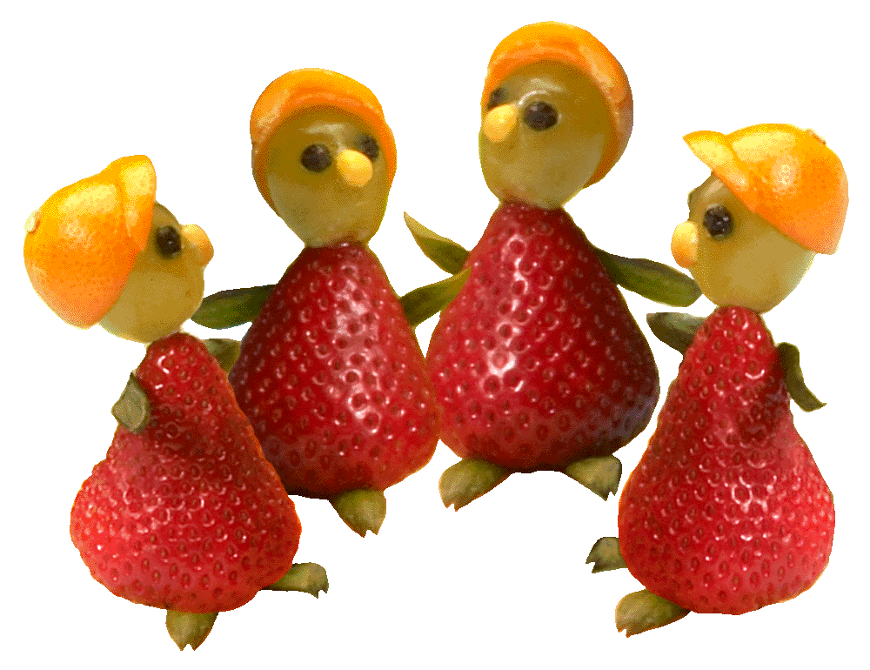
Join Your Friends
For Summer Meals
Free meals for children ages 1-18

Time:

Place:
USDA Summer Food Service Program
Eating with
friends
is really
GRAPE!
This institution is an equal opportunity provider.

